Addition using SOAP

1.Click on file and select "New"=> "Application" as shown below.

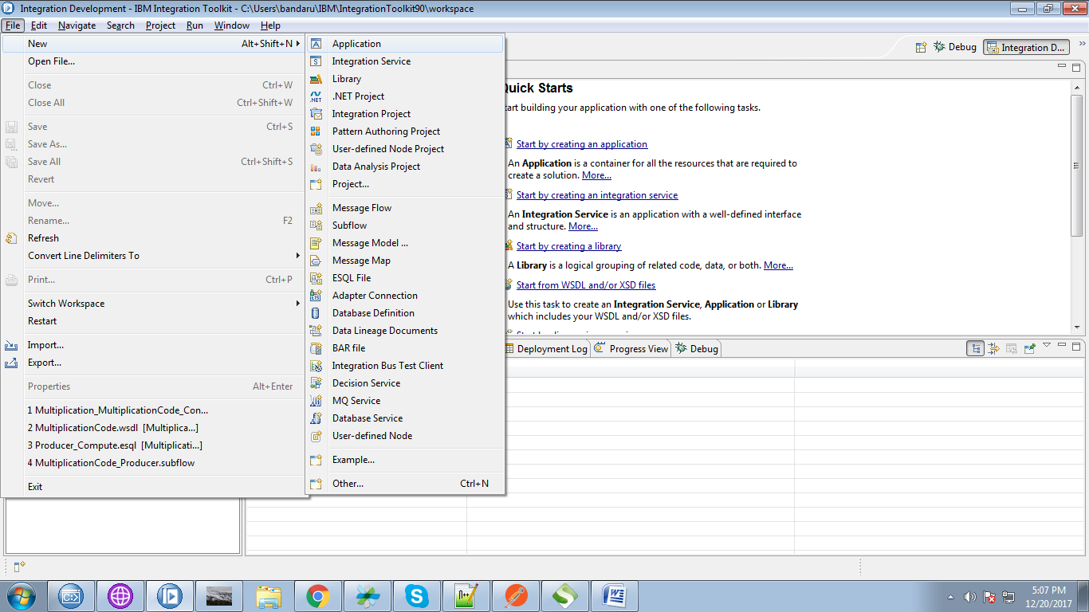

2. Give a name for your application and click "Finish" button.

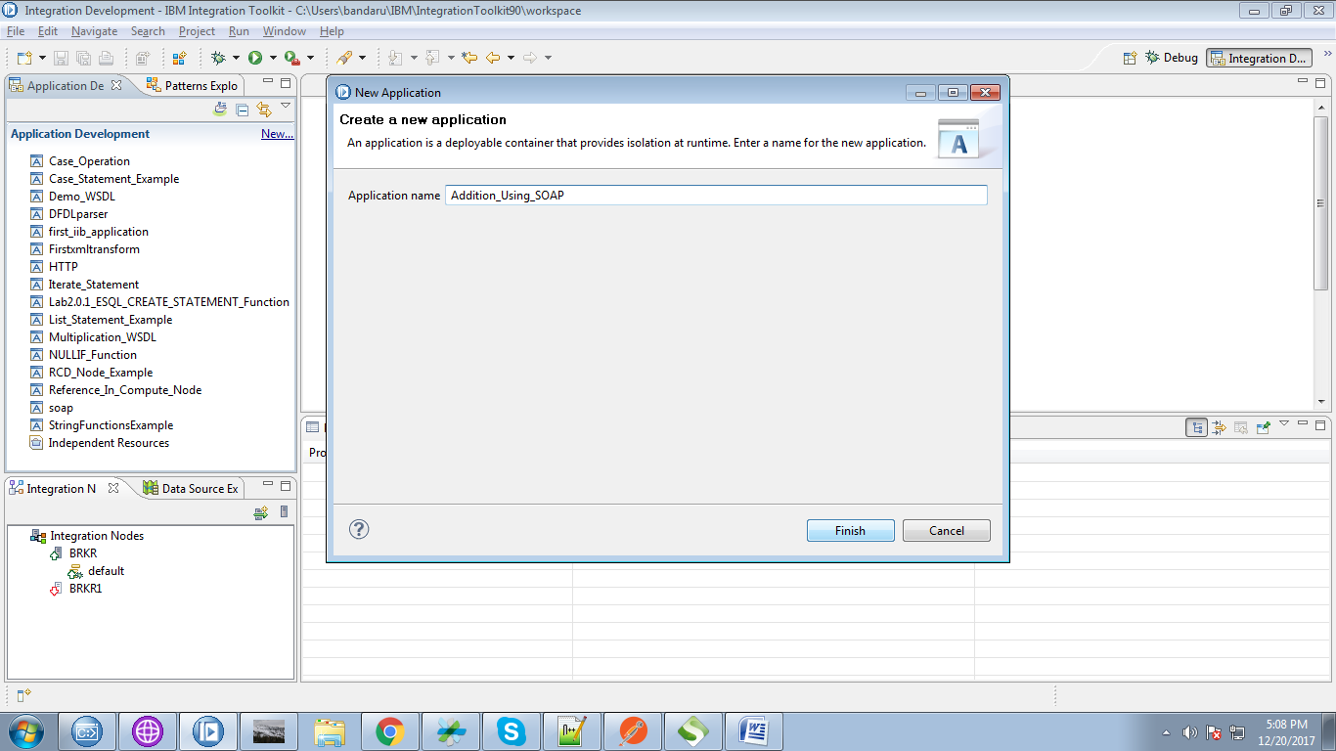

3. Right click on application and select "New"=> "Other".

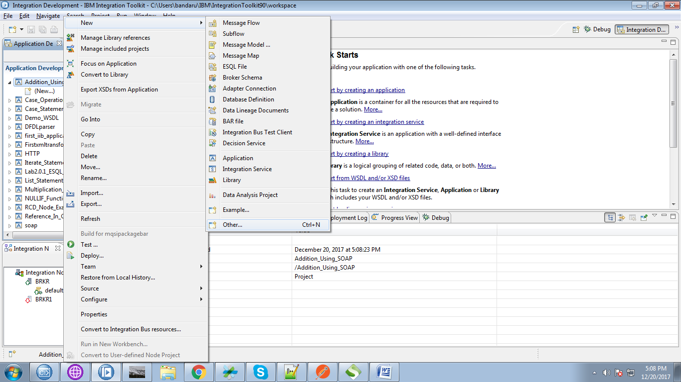

4. From the pop-up select "WSDL" from web services section.

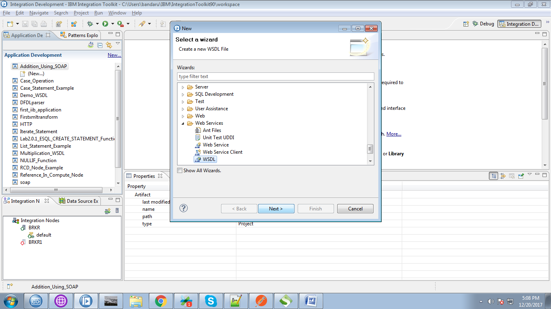

5. Give any name for your file and click on "Next" button.

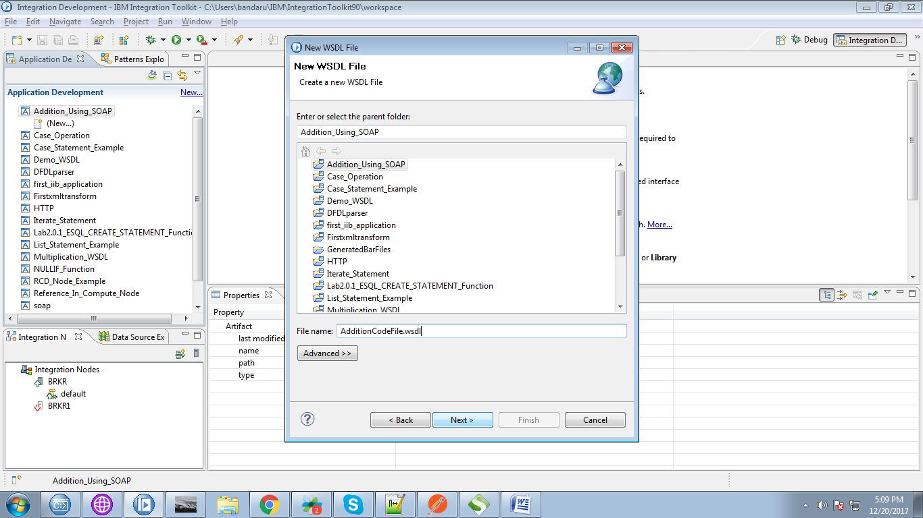

6. Click on "Finish" button.

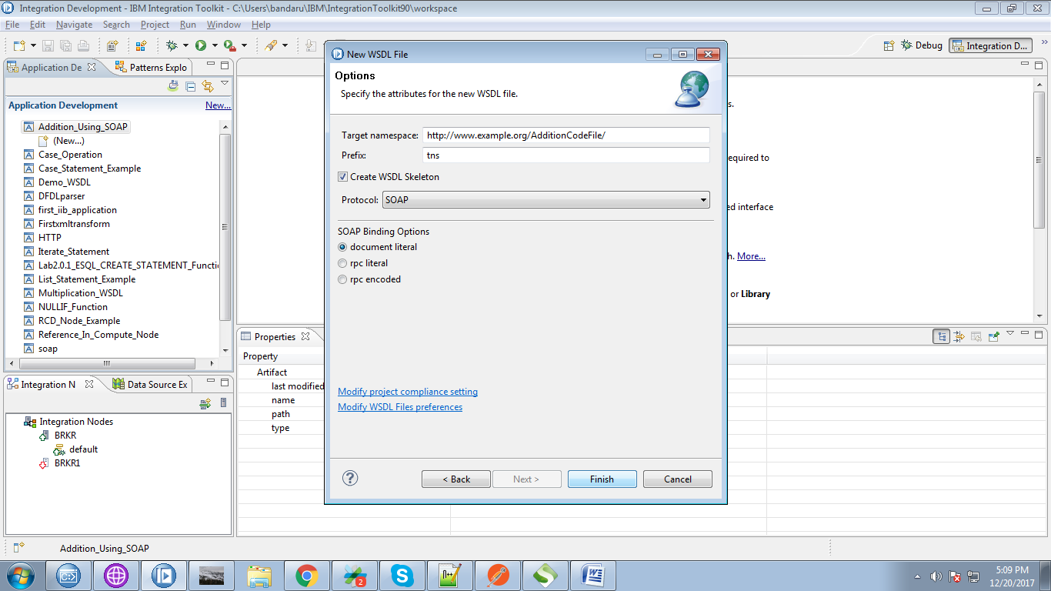

7. WSDL file will be generated as follows.

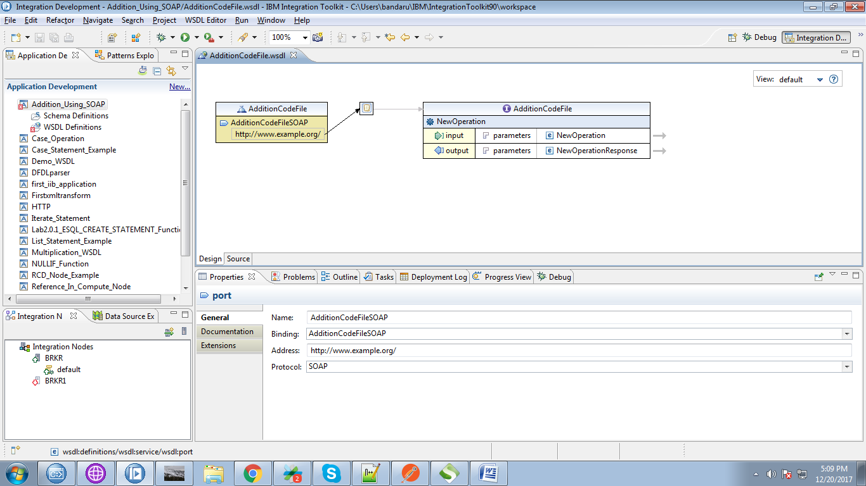

8. Check, on which ports your broker is running, For this, right click on your execution group and select "Properties".

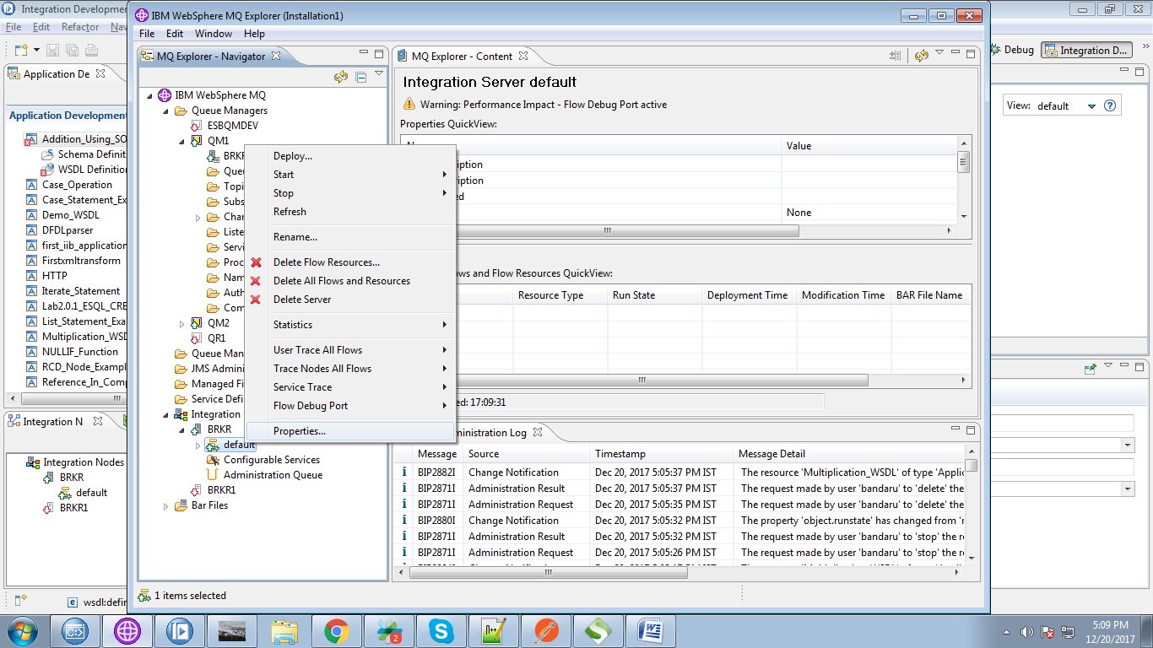

9. Under "Extended" tab, you can see your ports, use HTTP port(as we are not setting any SSL in our application)

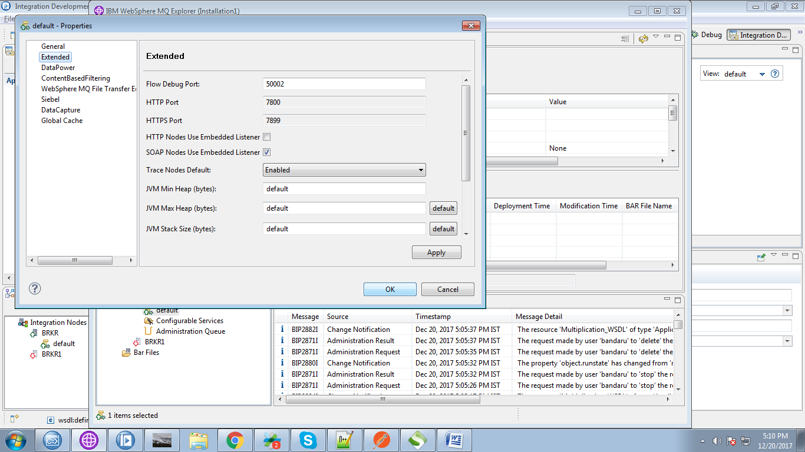

10. Here i used HTTP port here.

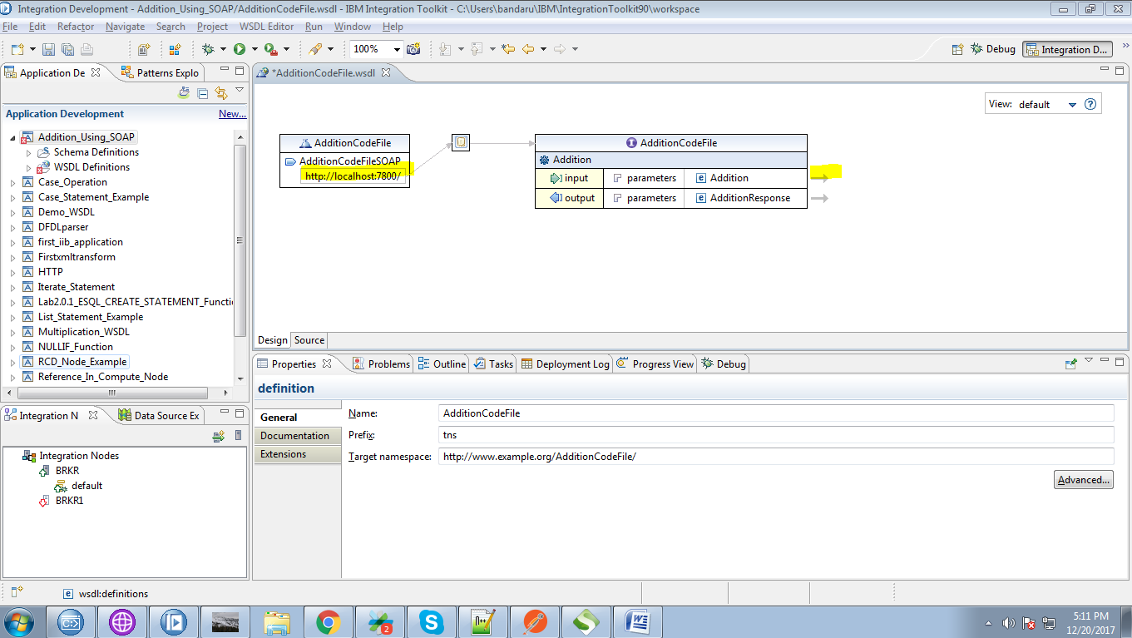

11. You can add additional elements by right clicking on elements tab and selecting "Add Element" as below fig.

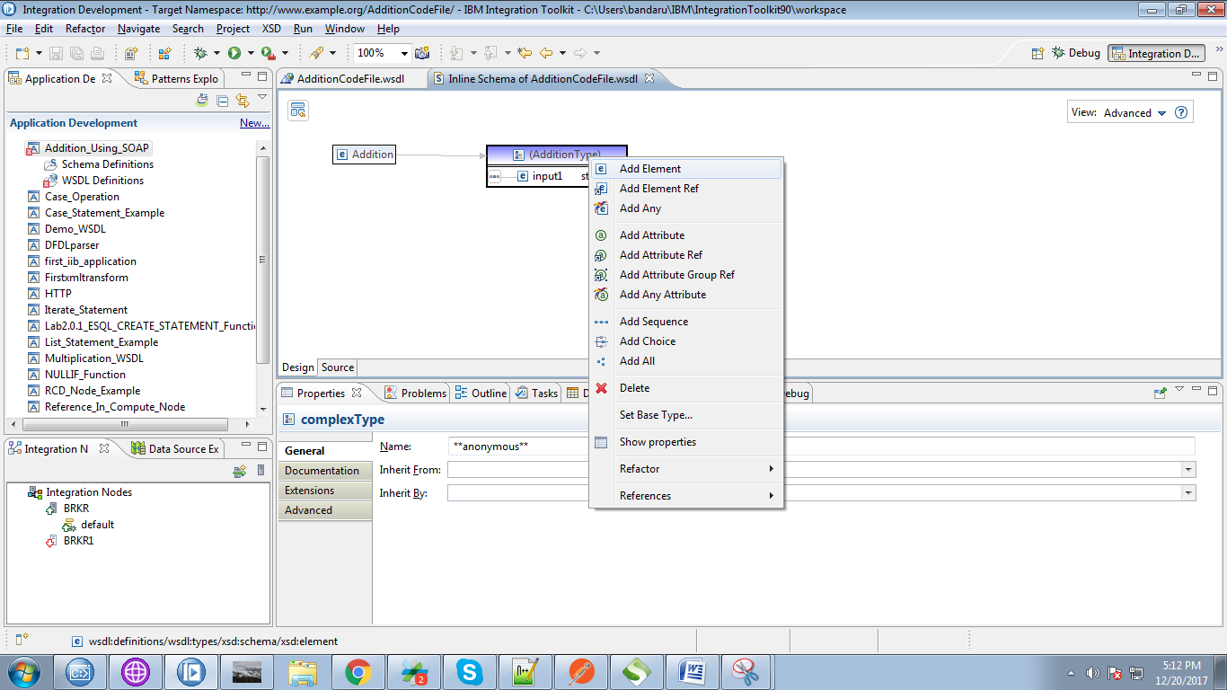

12. Here i added "input2" as another element.

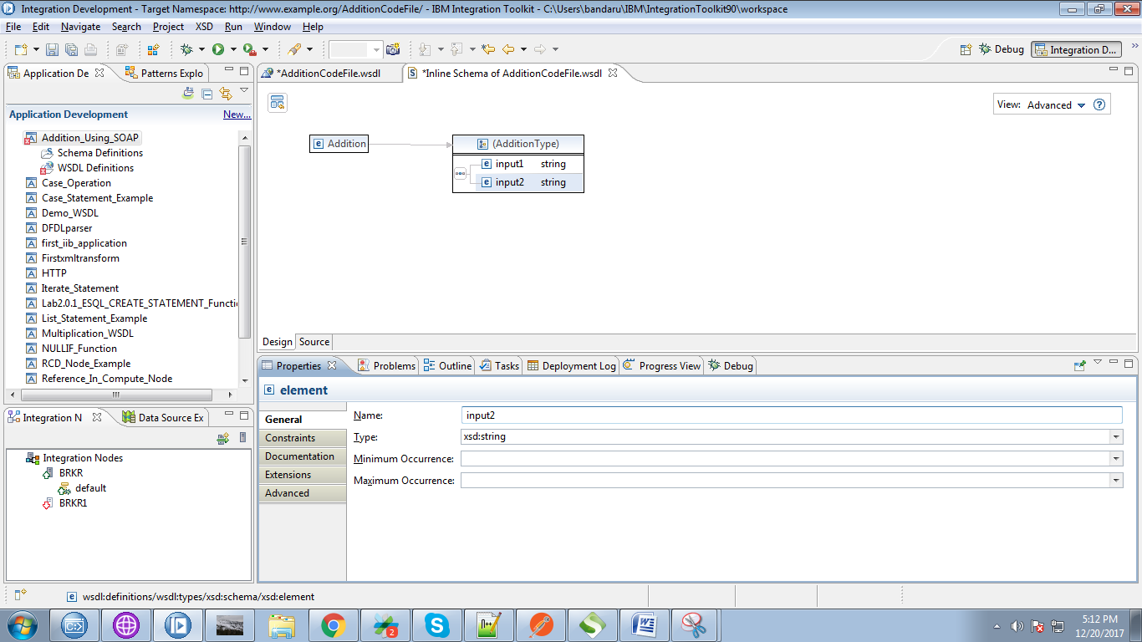

13. Now right click on your application and select "New"=>"Message Model"

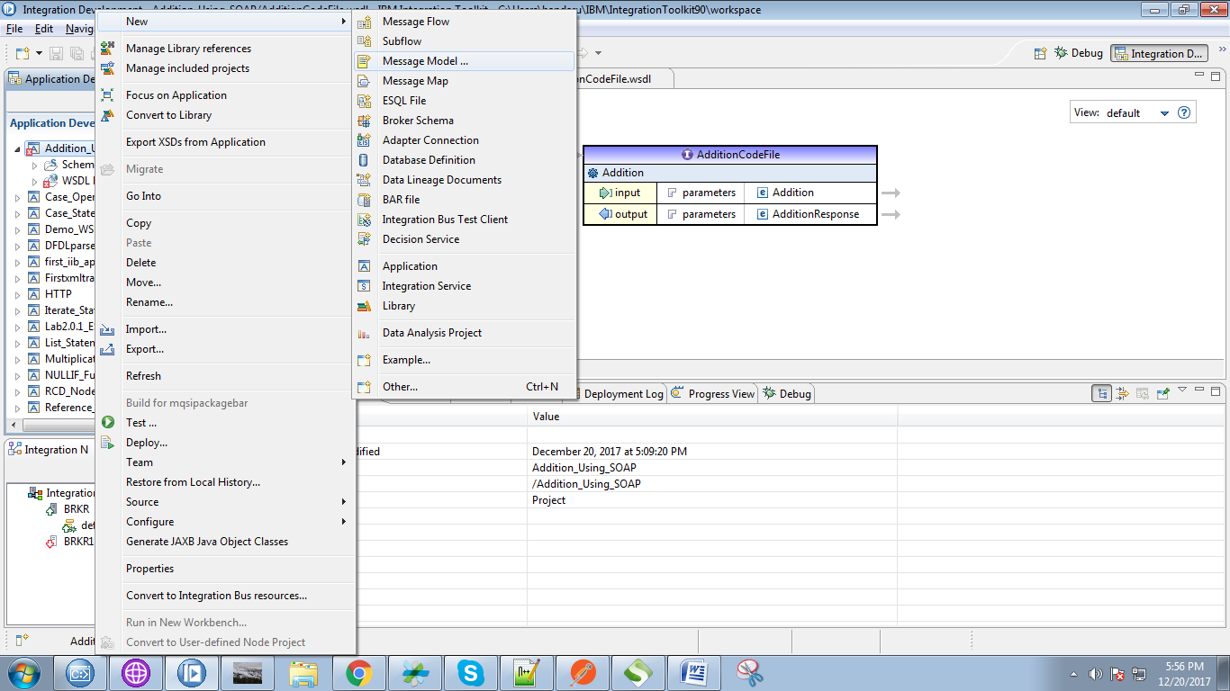

14. Select "SOAP XML" check box and click "Next" button.

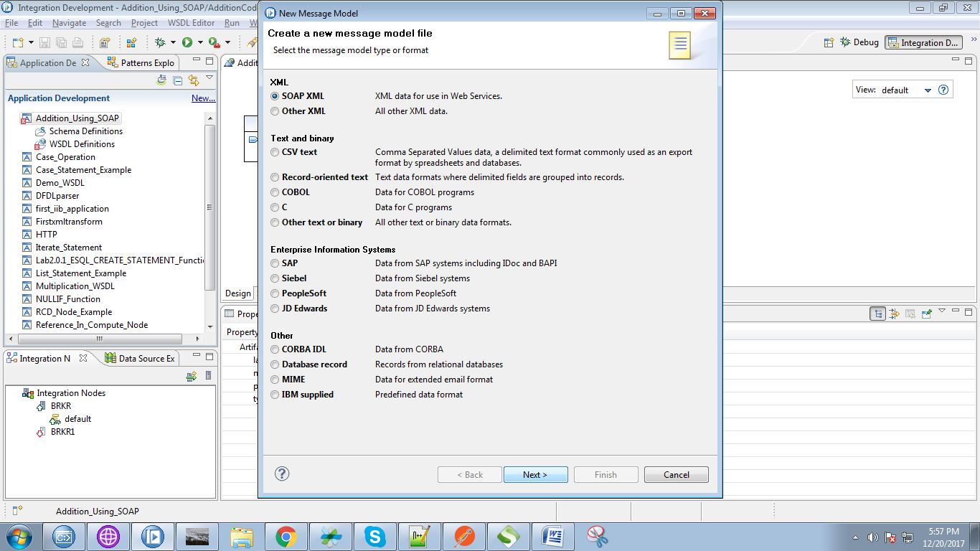

15. Select the "I already have WSDL from my data" and click "Next" button.

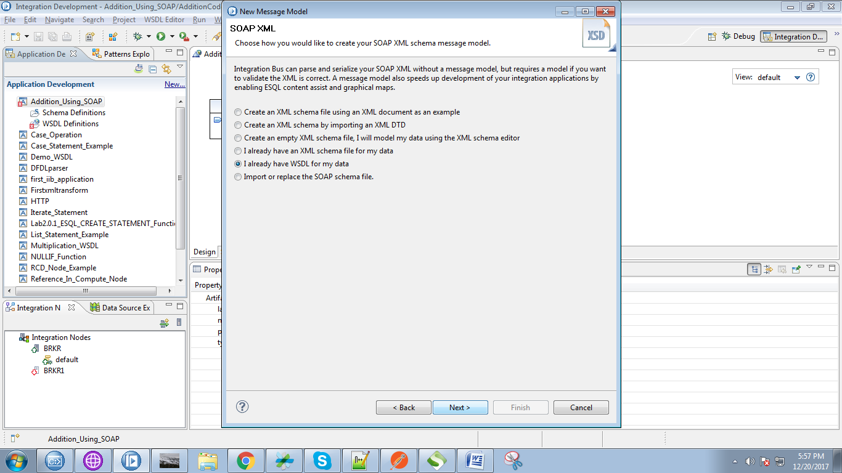

16. Select your WSDL created from the search console and click "Next" button.

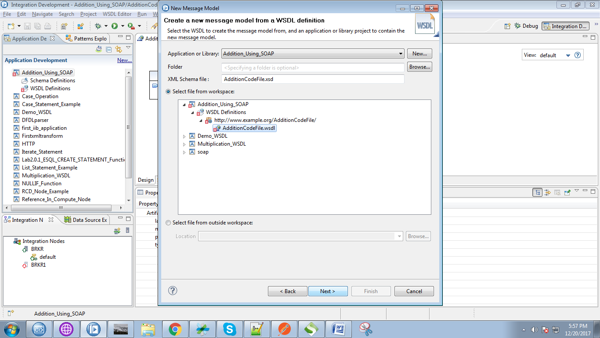

17. Click on "Finish" button finally.

NOTE: what ever changes made in wsdl file, you must again follow the "Message Model" steps.

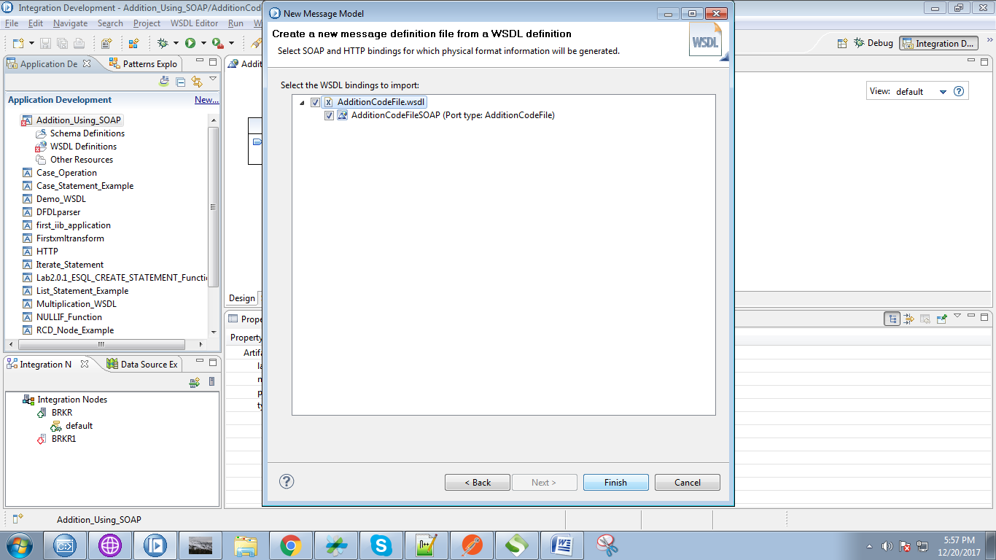

18. Right click on application and select "New"=>"Message Flow".

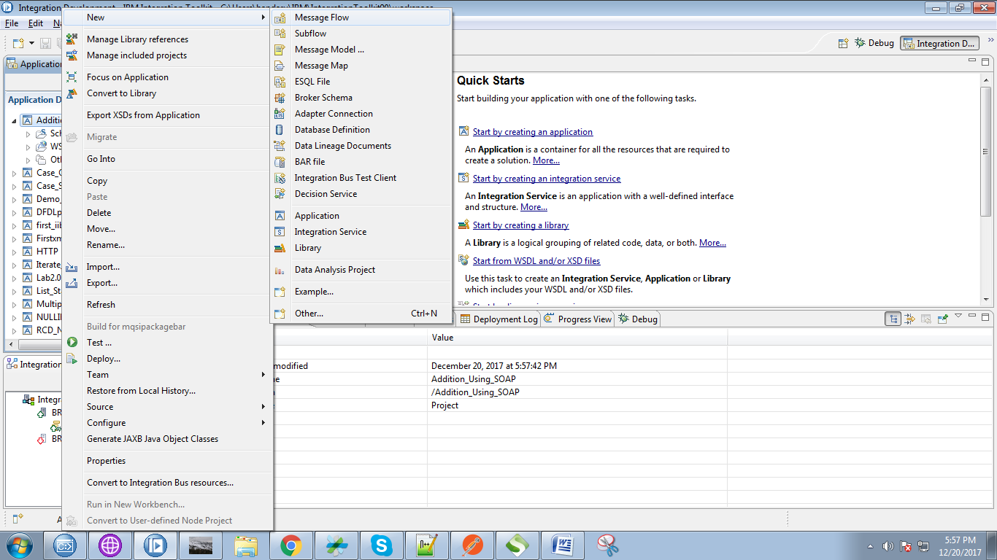

19. Now first we create producer flow,so give the name as producer and click on "Finish" button.

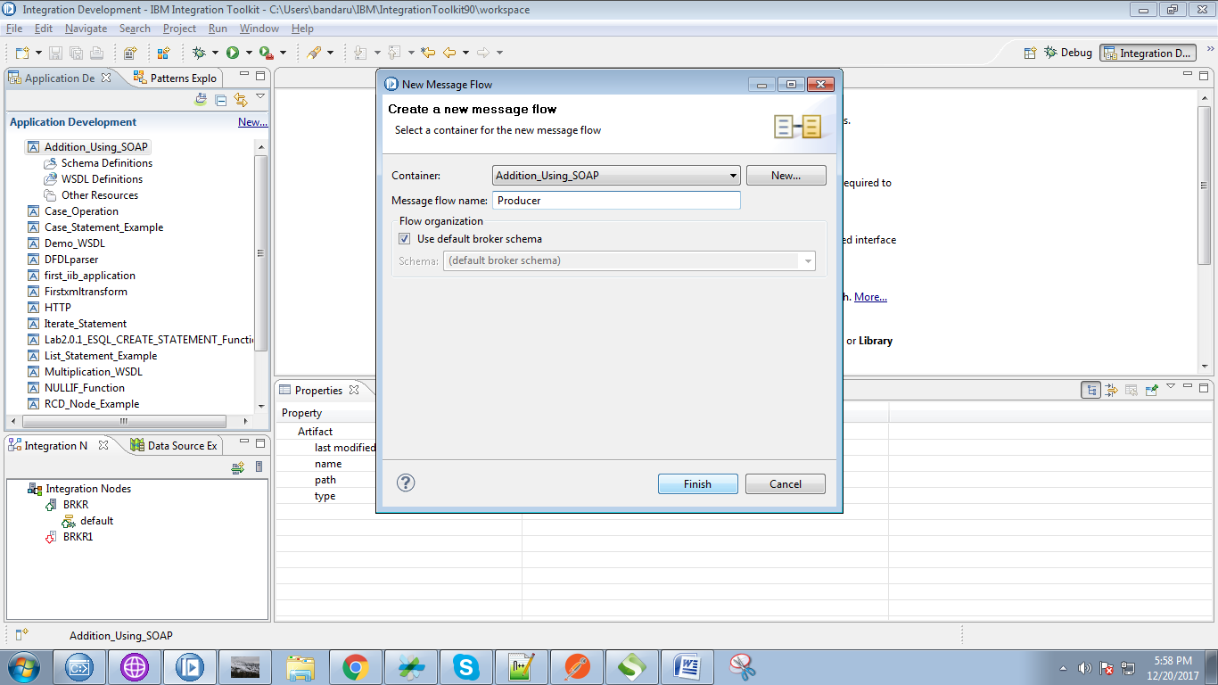

20. Drag your WSDL file on to producer flow, Following pop-up will appears.

* Select "Expose....." option from the top radio buttons.
* Click on "Finish" button.

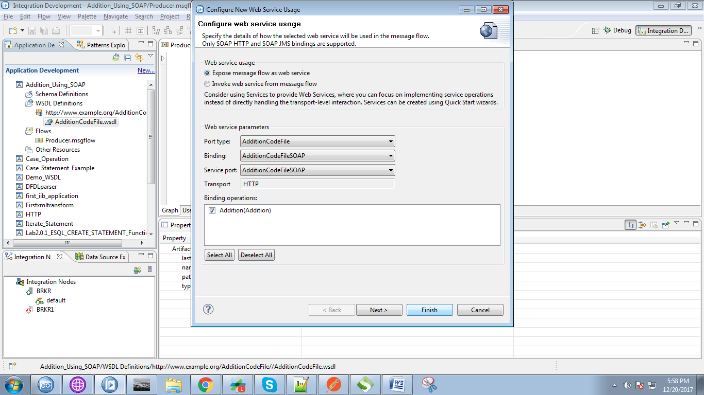

21. Your producer flow will generated as given below. Under SOPA node give path url as "addition"

NOTE: this path should match with path in "Request" node in consumer.

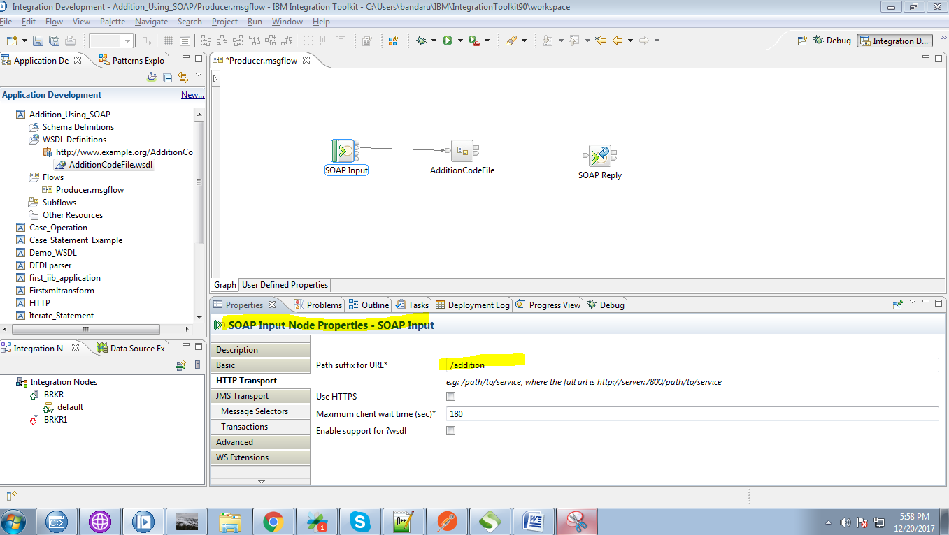

22. Drag the compute node from the "transformation" section.

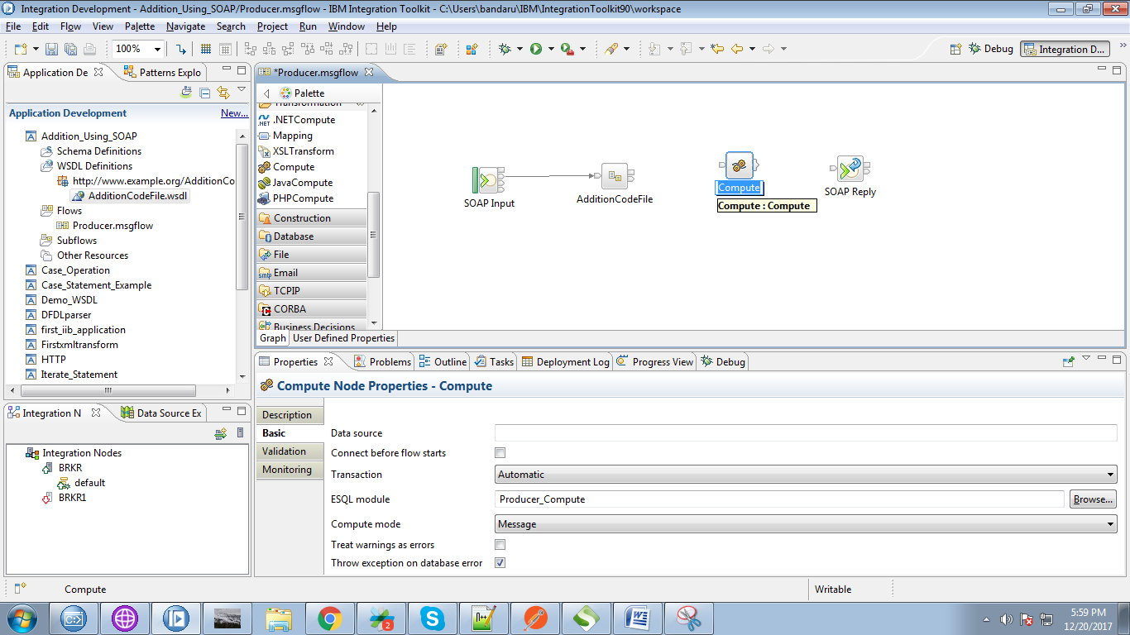

23. Connect "Addition" terminal of the producer SOAP process node to "input" terminal of the compute node.

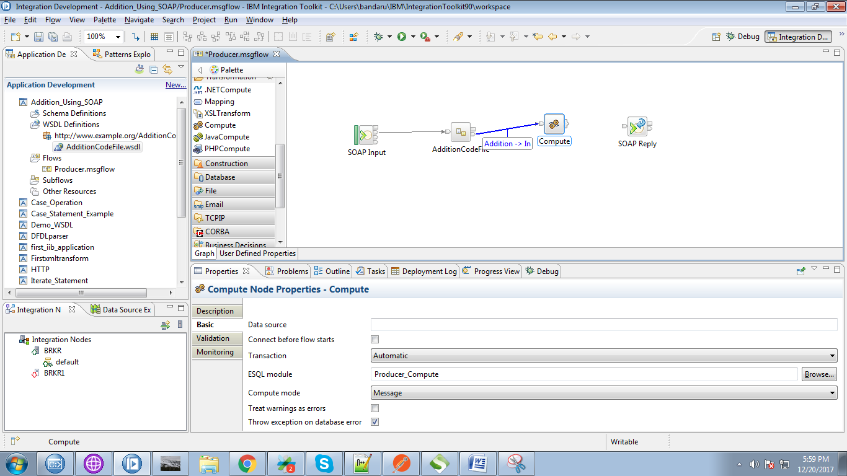

24. Click on output terminals of the compute node and select "Out" and click "OK" button.

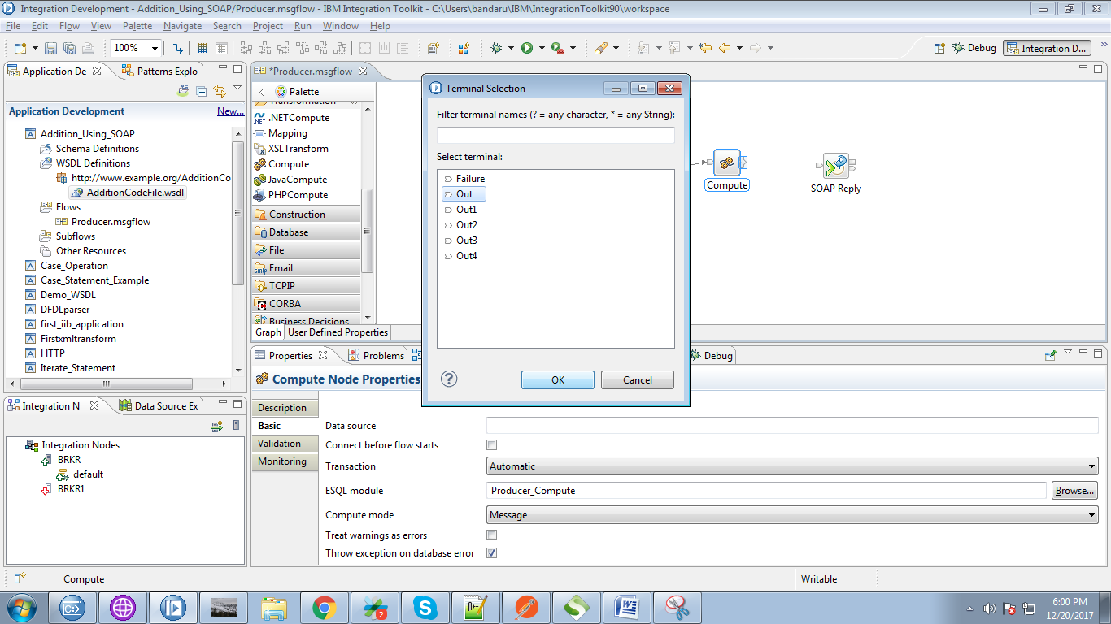

25. Connect "output" terminal of the compute node with the "input" terminal of the SOAP Reply.

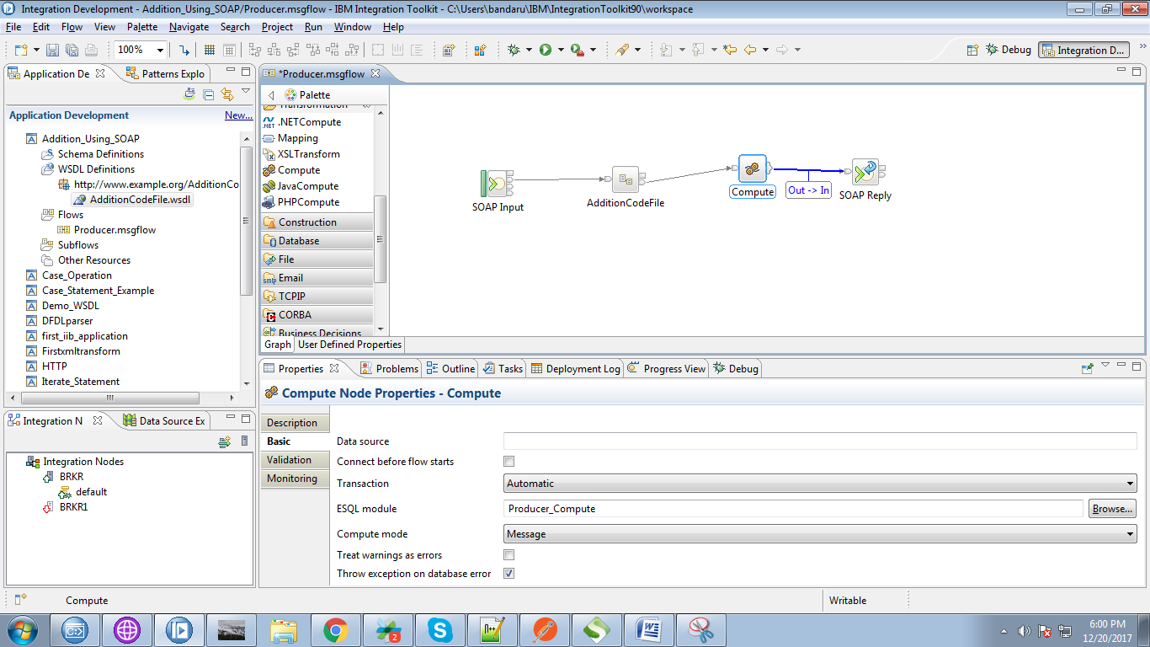

26. Override the following code in compute node.

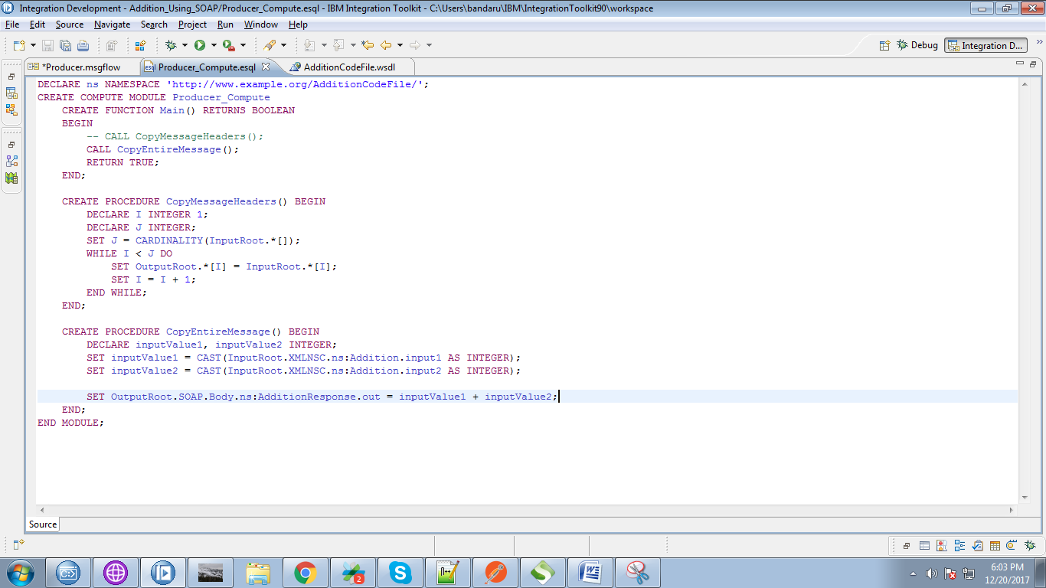

27. Now we create consumer flows. For this right click on application and select "New"=>"Message Flow".

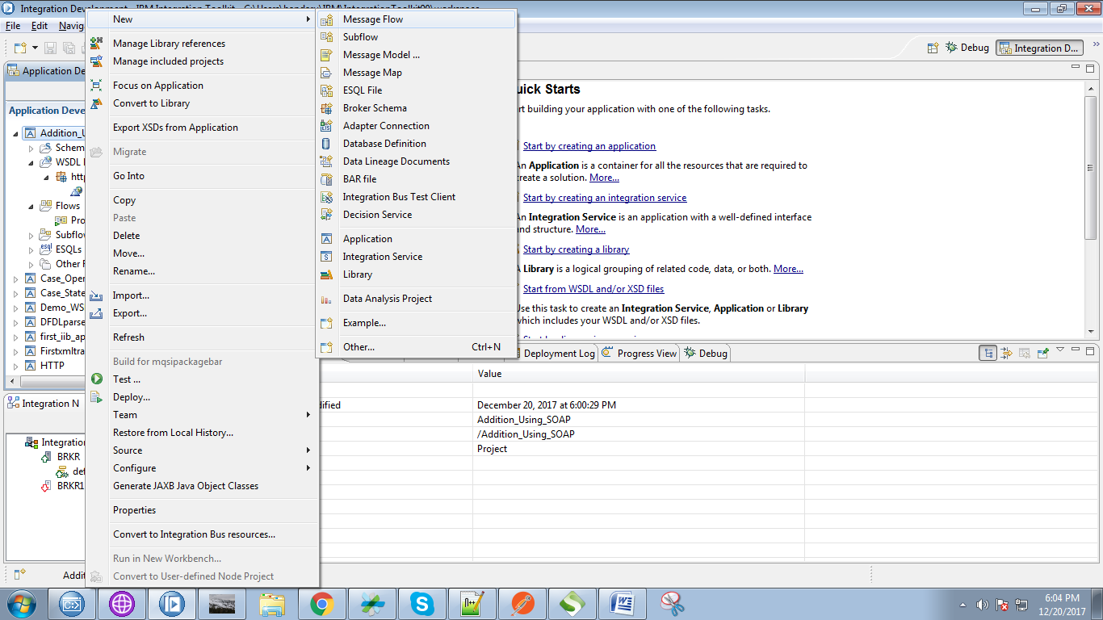

28. Give a name for your flow and click on "Finish" button.

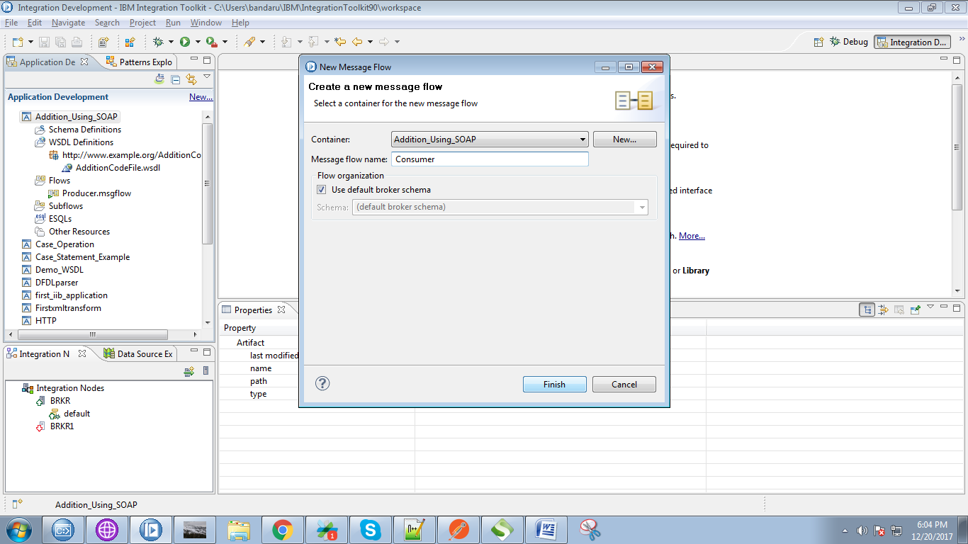

29. Now drag your WSDL file on to consumer flow, then following pop-up will appears and select "Invoke web service......." radio button and click "Finish" button.

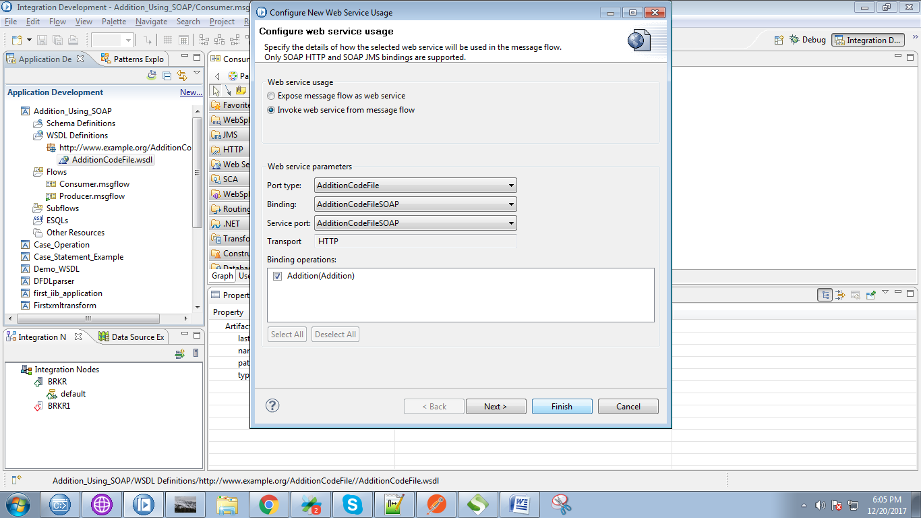

30. Your consumer flow looks like following flow.

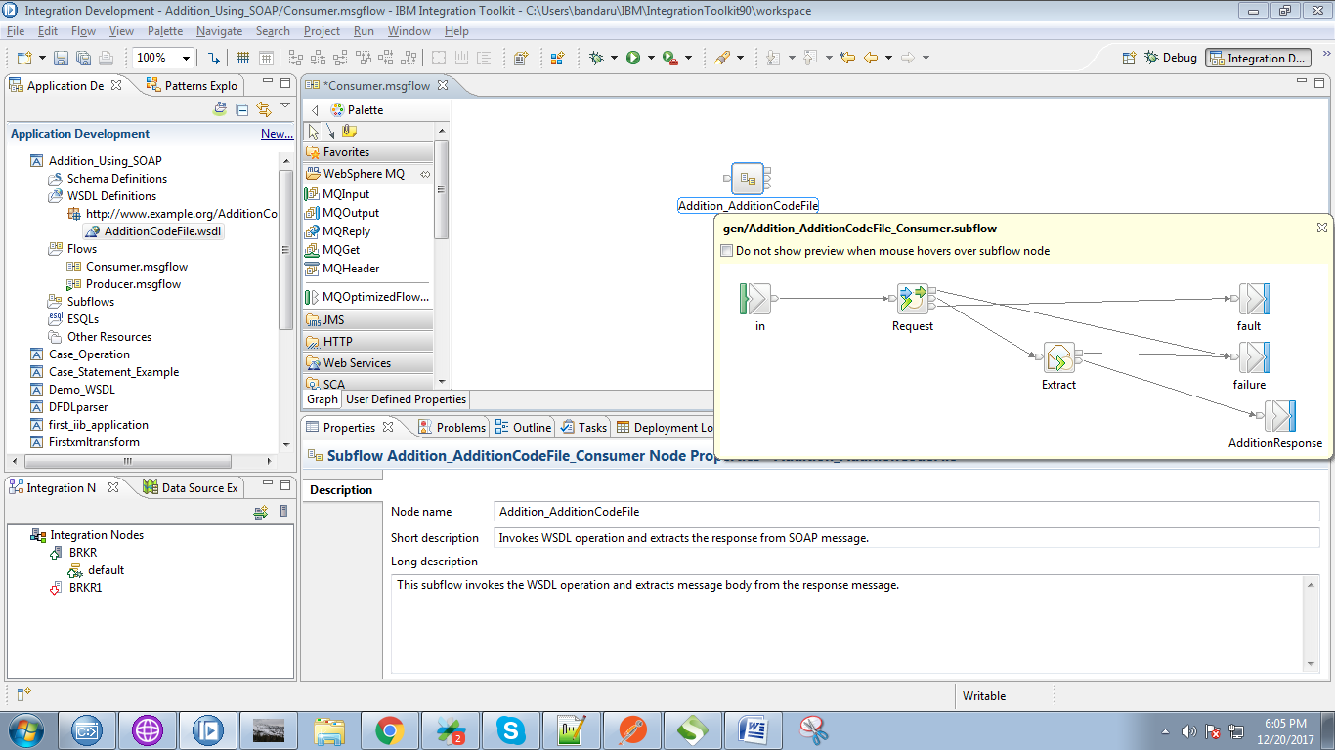

31. Drag MQInput from the WebSphere MQ section and give it a name.

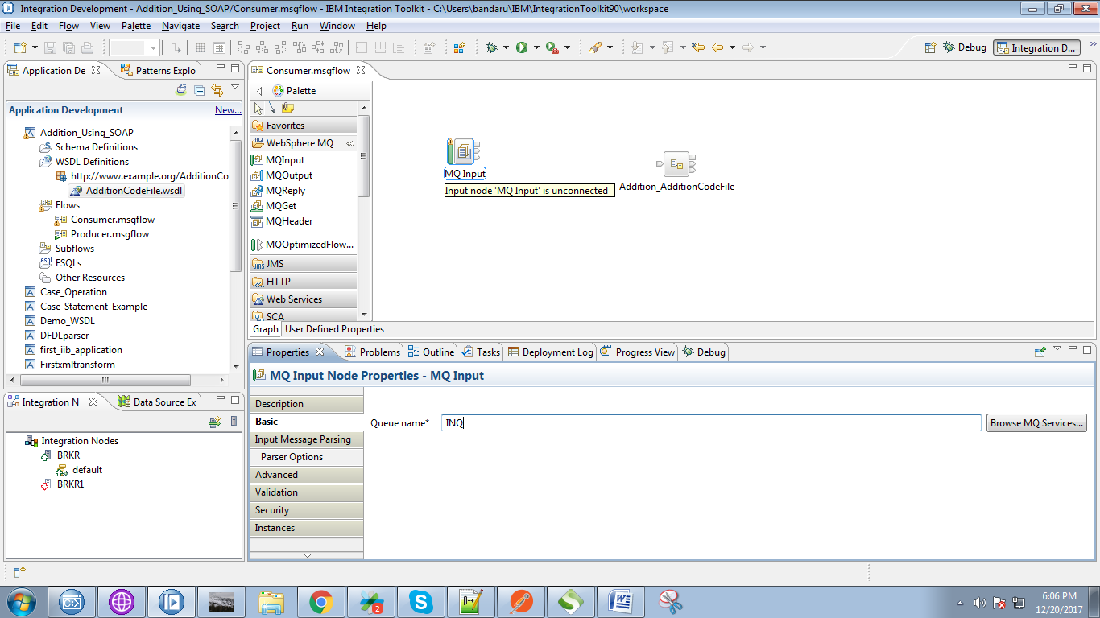

32. Select XMLNSC as "Message domain" for the MQInput.

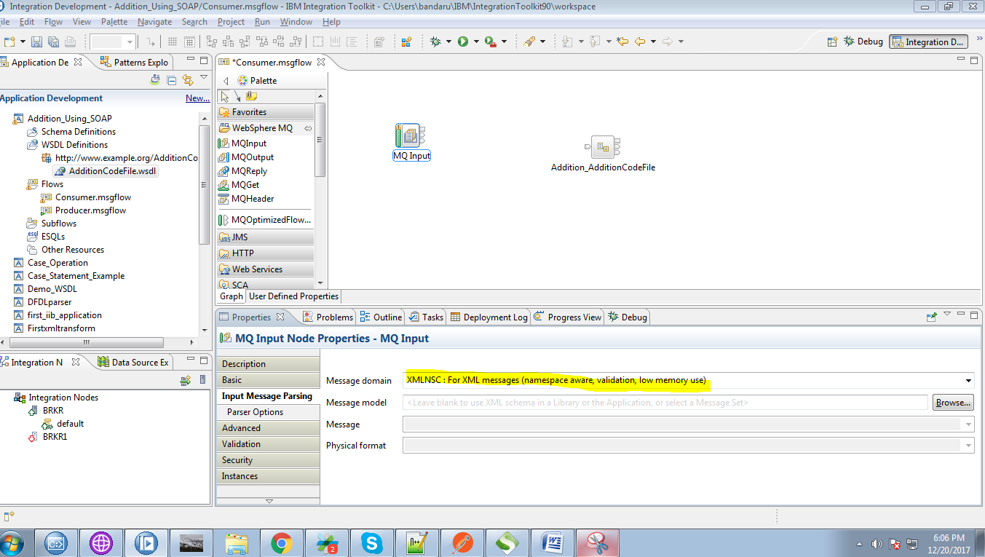

33. Drag the compute node from the transformation section.

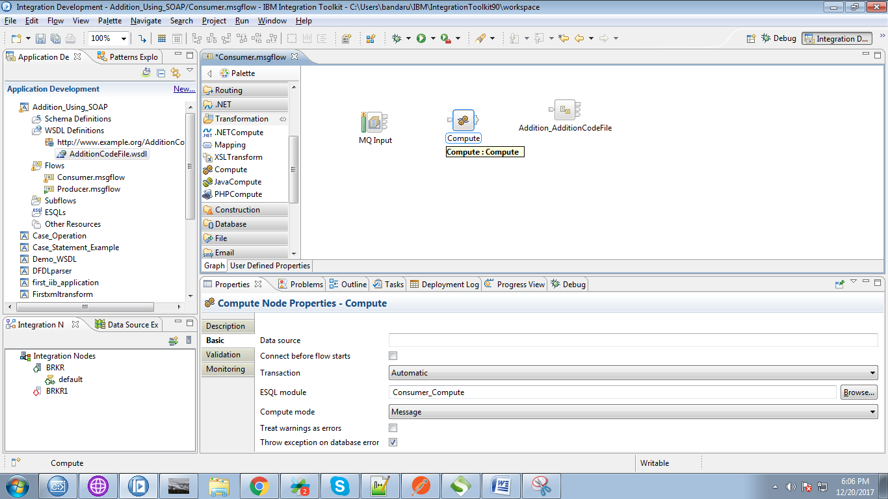

34. Connect "output" of the MQInput with the "input" of the compute node.

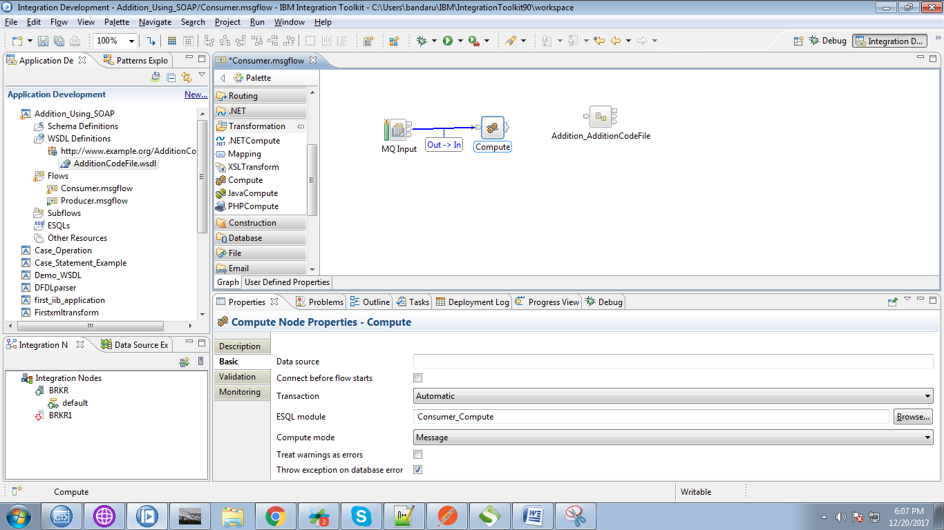

35. Click on output terminal of the compute node and select "Out" and click on "OK" button.

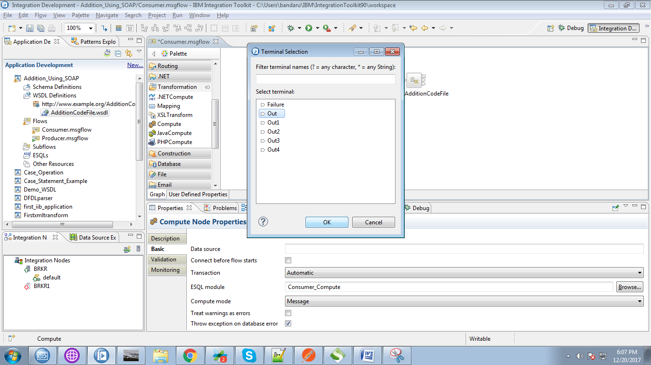

36. Connect "output" terminal of the compute node with "input" terminal of the consumer process.

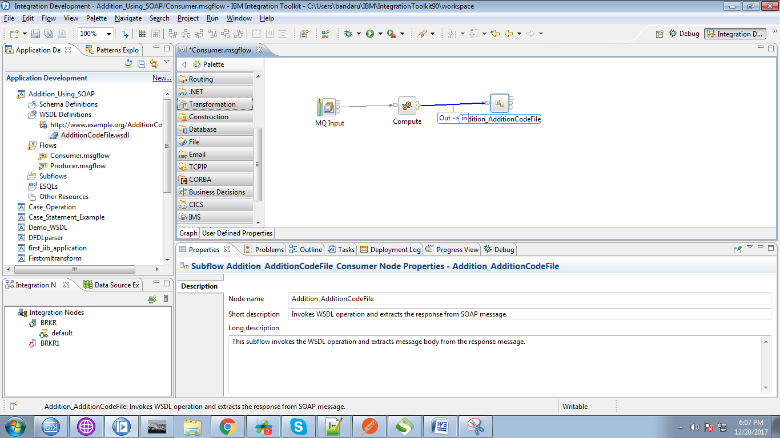

37. Drag MQOutput from the WebSphere MQ section and give it a name.

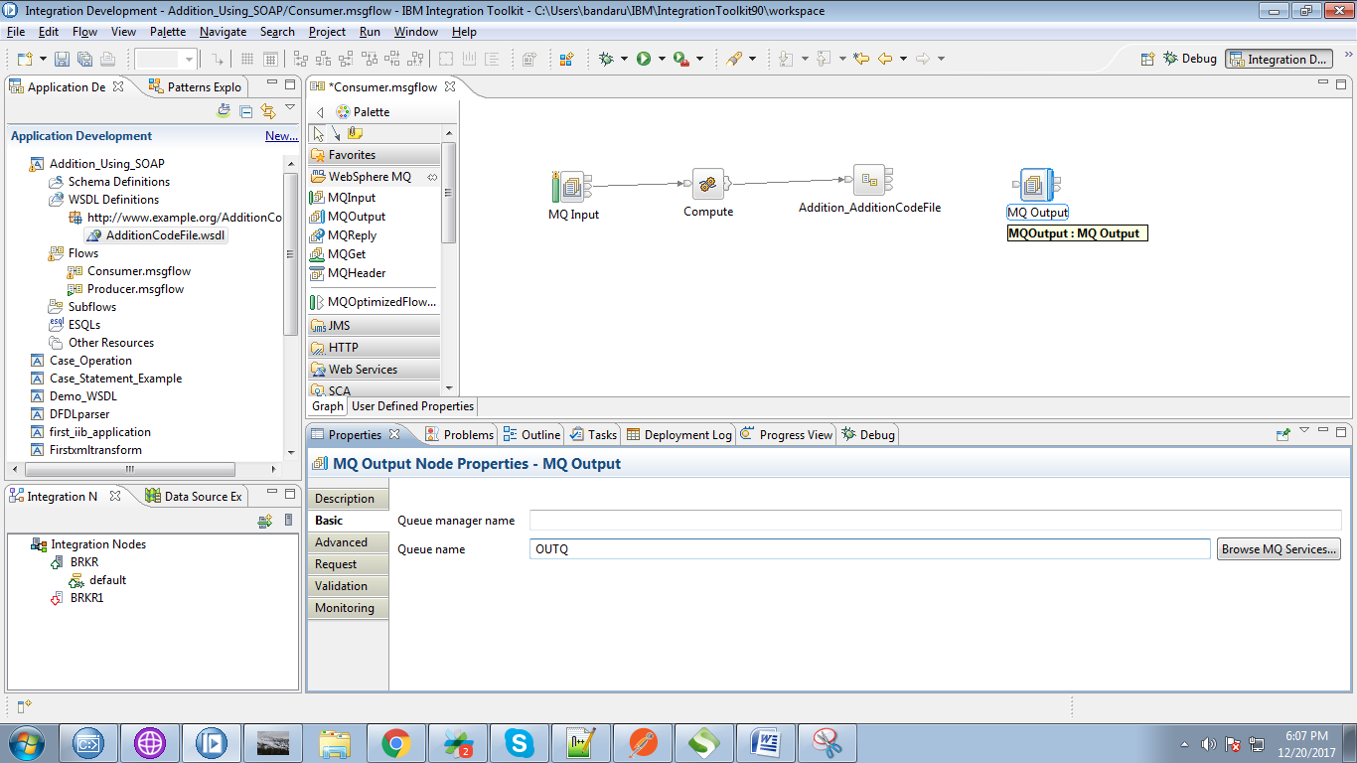

38. Connect "AdditionResponse" of the consumer process with "input" terminal of the MQOutput.

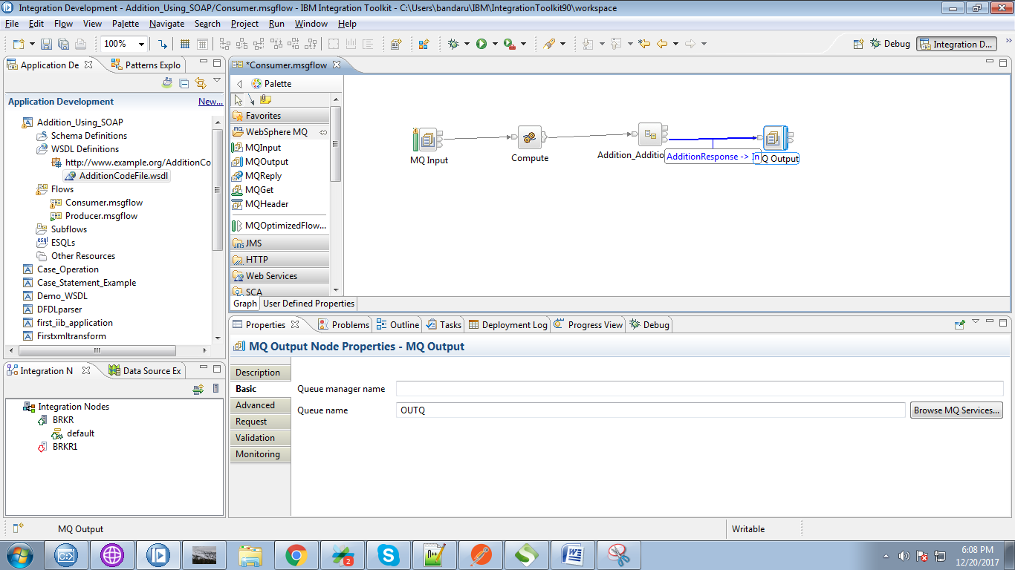

39. Override the following code in the compute node.

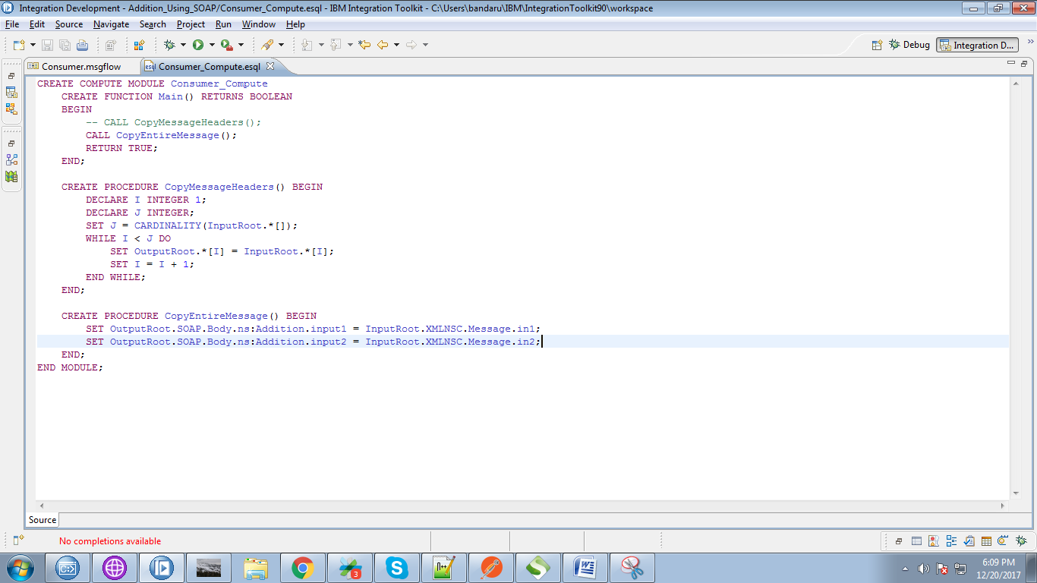

40. Backend process of the consumer flow looks as below fig. Give any path(as "addition" here)

for the "Request" node

NOTE: this path should be matched with path in SOAP node in producer.

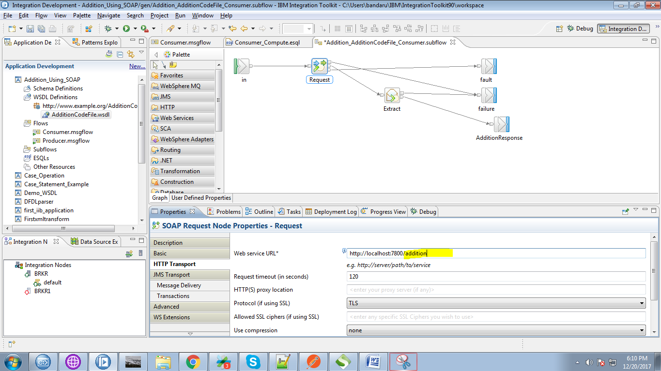

41. Right click on application and select "Deploy" option.

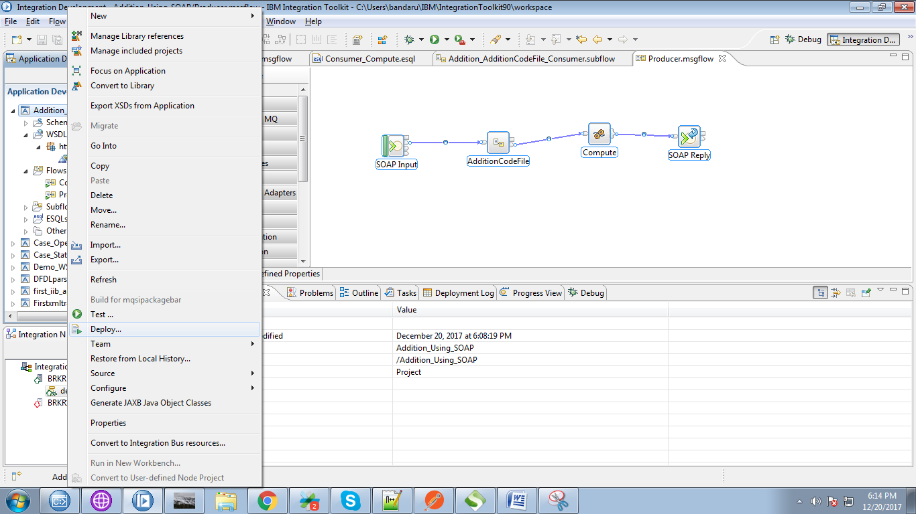

42. Select your running broker and execution group and click on "Finish" button.

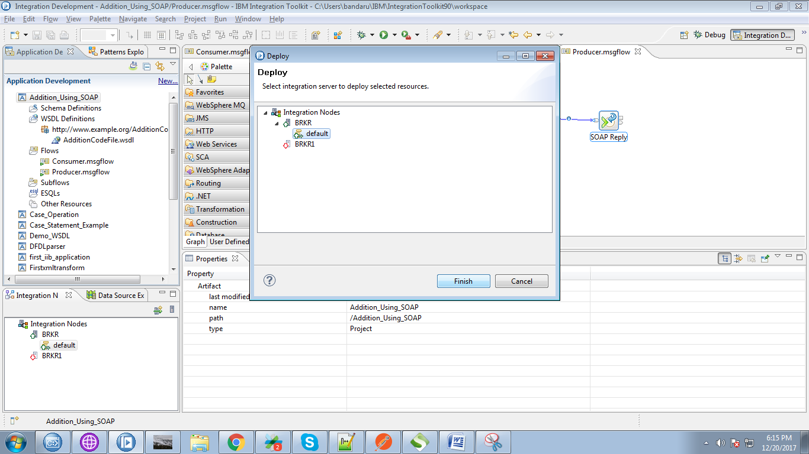

43. Create appropriate queues in WebSphere MQ Explorer.

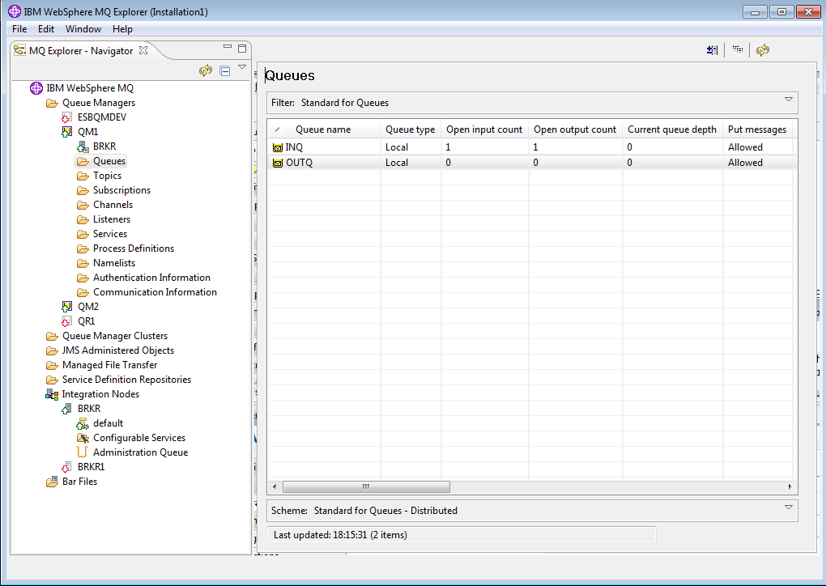

44. Selec your Queue Manager and Queue Name and click "Open File" button and browse your input file.

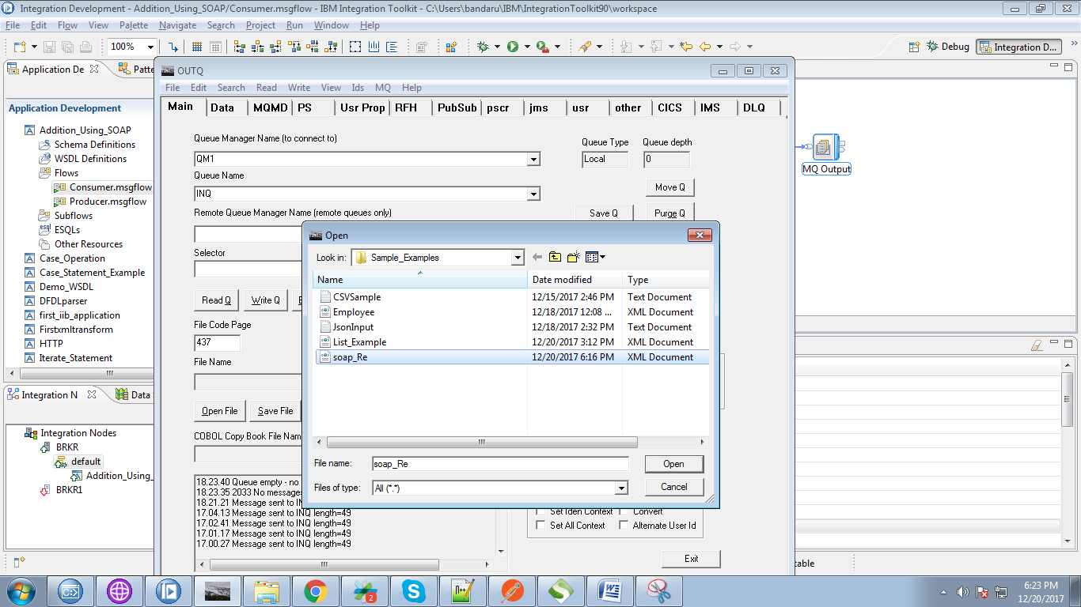

45. Our input file contains following data.

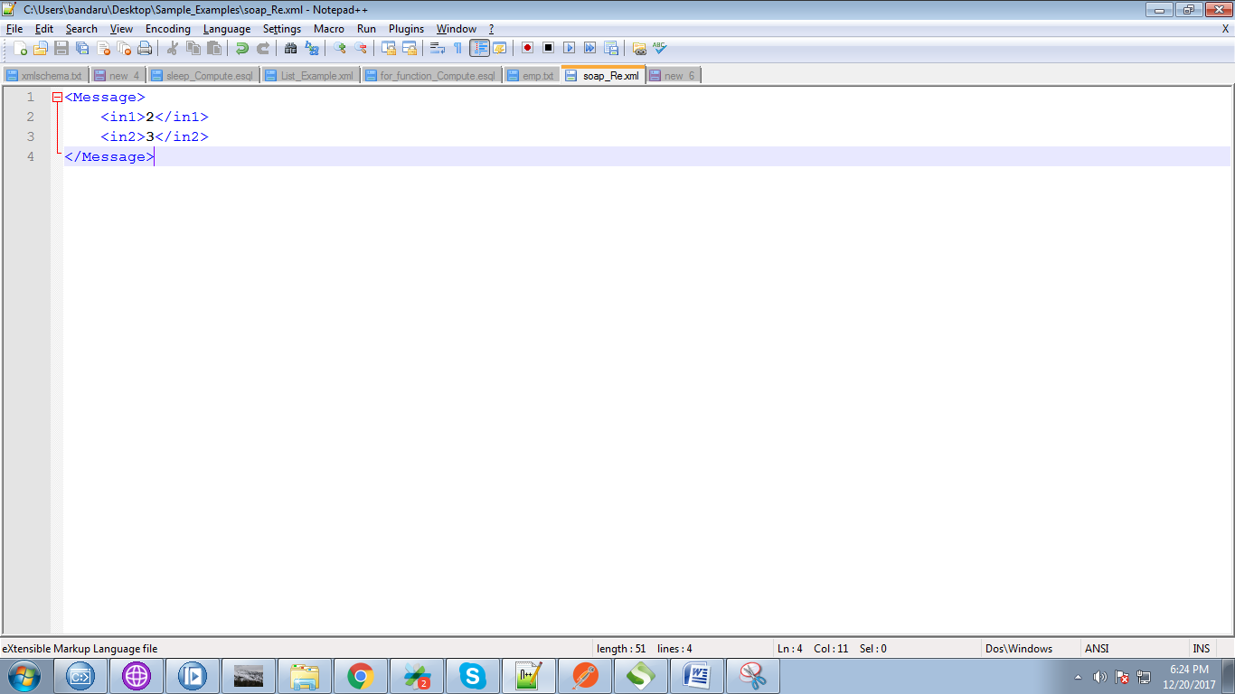

46. Now hit "Write Q" to trigger your flow.

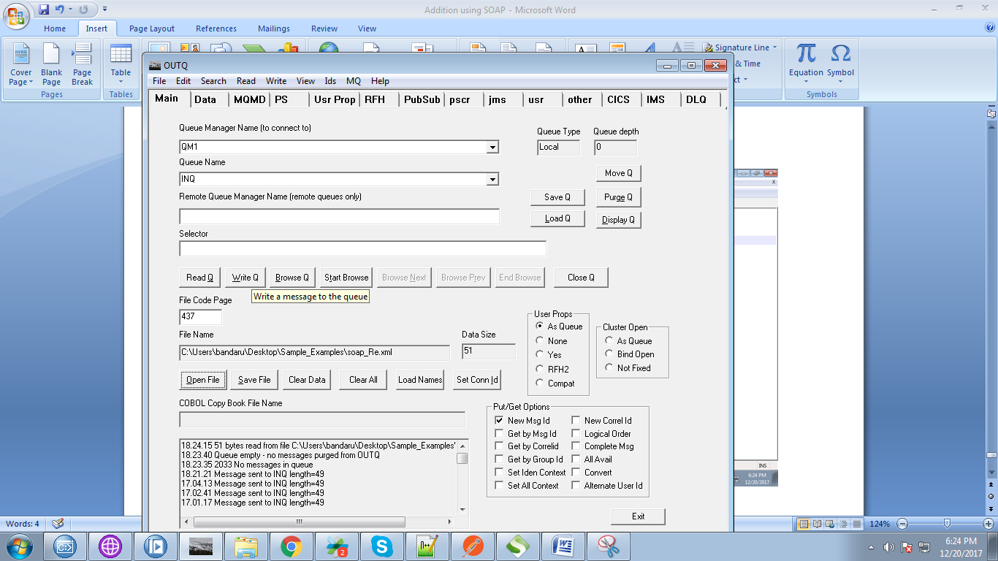

47. You can see input values set to SOAP parameters while flow in debug mode.

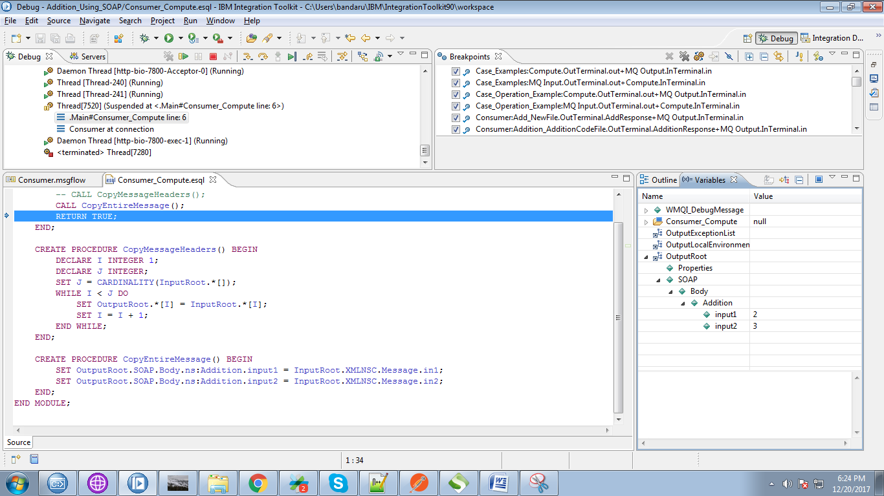

48. Input values are set at SOAP node in producer flow.

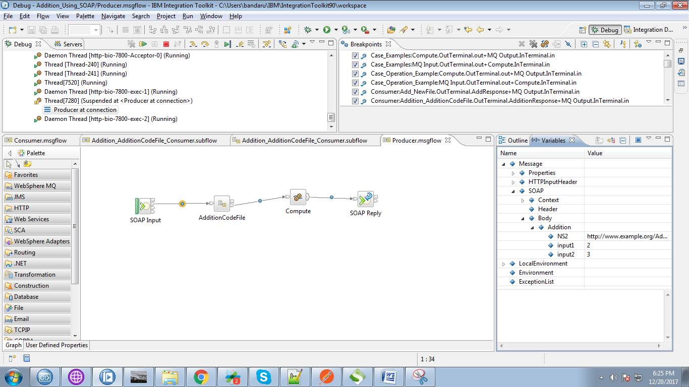

49. You can able to see addition value(5 in variables tab) after compute node.

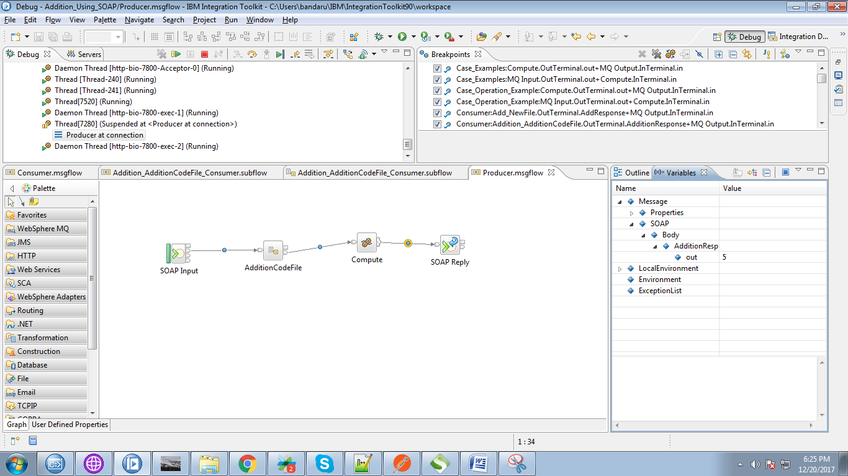

50. Output will send to MQOutput.

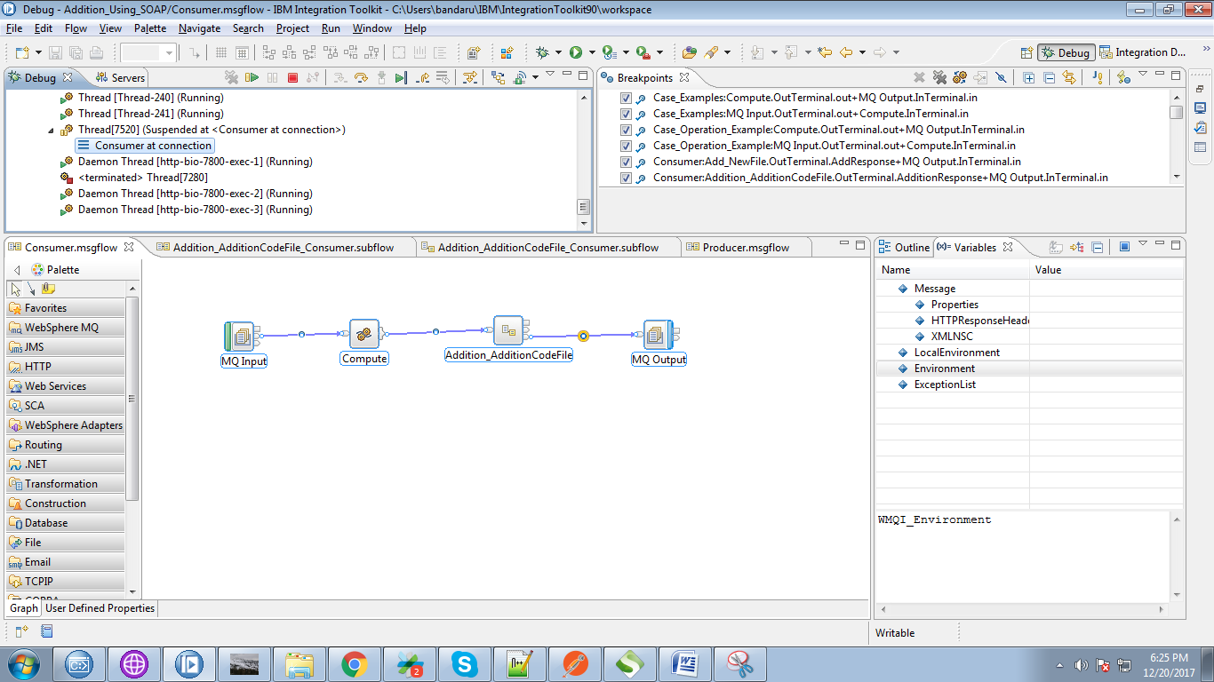

51. Select your output queue and click on "Browse Q" button.

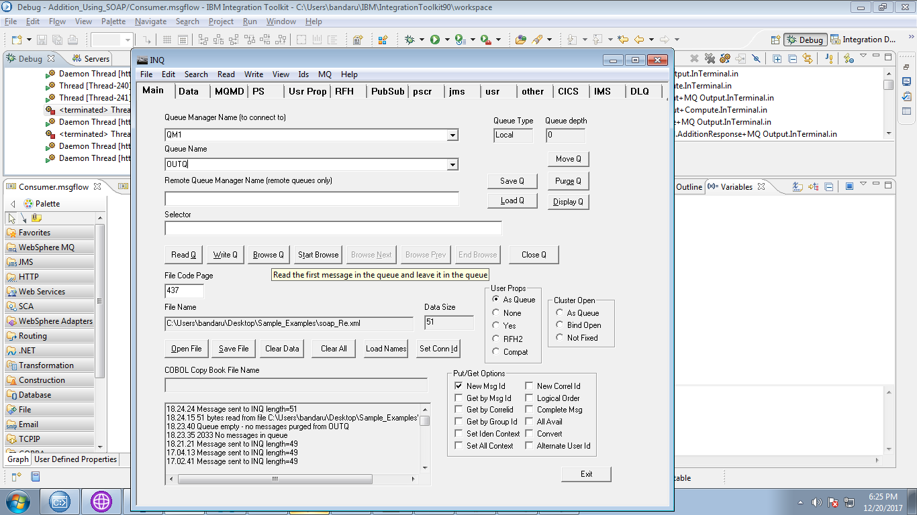

52. You can see your output at "Data" tab of rfhutil.

